# Informações do estudo

Referência: Chinchanikar 35

Grandeza: Rugosidade

Tipo: Ra

Material: AISI 4340 (35 HRC)

Ferramenta: KC9110

Número de experimentos: 20

Observações:  
Tool holder: PCBNR 2020K12  
Diameter: 90 mm  
Piezo-electric dynamometer: KISTLER Type 9257A  
Surface roughness tester: Qualitest TR100

# Unidades

Velocidade: m/min

Avanço: mm/rev

Profundidade de corte: mm

Rugosidade: μm

# Dados de teste

|  |  |  |  |
| --- | --- | --- | --- |
| Rugosidade | n | f | a |
| 6.48 | 200.0 | 0.3 | 1.5 |
| 4.89 | 265.0 | 0.15 | 2.0 |
| 6.81 | 142.0 | 0.25 | 2.0 |
| 5.39 | 200.0 | 0.2 | 1.5 |

# Dados de treino

|  |  |  |  |
| --- | --- | --- | --- |
| Rugosidade | n | f | a |
| 5.48 | 200.0 | 0.2 | 1.5 |
| 6.48 | 265.0 | 0.25 | 2.0 |
| 5.29 | 200.0 | 0.2 | 1.5 |
| 5.73 | 142.0 | 0.15 | 2.0 |
| 5.07 | 265.0 | 0.25 | 1.0 |
| 4.98 | 200.0 | 0.1 | 1.5 |
| 5.25 | 200.0 | 0.2 | 1.5 |
| 5.76 | 142.0 | 0.25 | 1.0 |
| 5.45 | 300.0 | 0.2 | 1.5 |
| 5.37 | 200.0 | 0.2 | 1.5 |
| 6.36 | 200.0 | 0.2 | 2.5 |
| 5.53 | 200.0 | 0.2 | 1.5 |
| 5.03 | 200.0 | 0.2 | 0.5 |
| 4.65 | 265.0 | 0.15 | 1.0 |
| 6.18 | 100.0 | 0.2 | 1.5 |
| 5.71 | 142.0 | 0.15 | 1.0 |

# RN

Número de neurônios: 83

Taxa de aprendizado: 1.000000e-02

Número de épocas: 337

2° camada: True

Função de ativação: relu

# Erros

**Dados de teste**

* Erro relativo médio: 8.86
* Coeficiente de correlação: 0.92
* Coeficiente de determinação: 0.84
* MSE: 0.39
* RMSE: 0.62

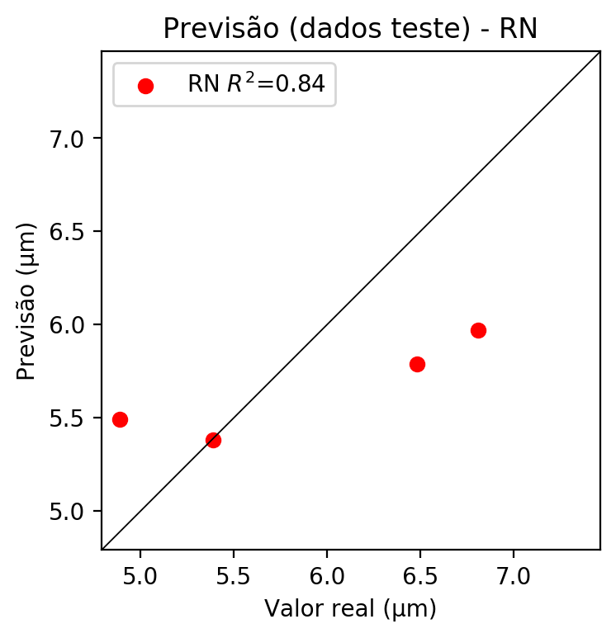

**Dados de treino**

* Erro relativo médio: 0.56
* Coeficiente de correlação: 0.99
* Coeficiente de determinação: 0.99
* MSE: 0.0
* RMSE: 0.0

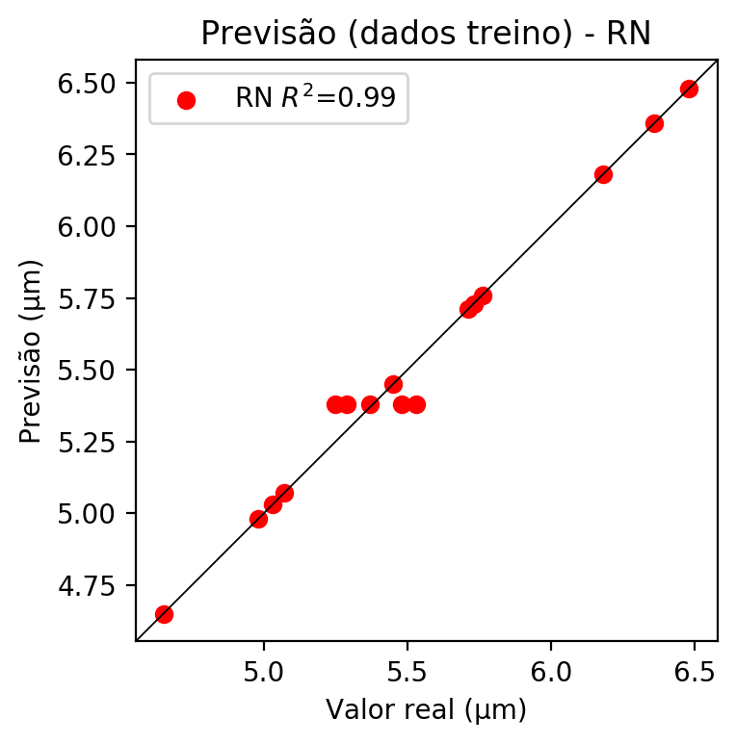

# Pesos

Pesos - camada oculta 1

[[ 0.12070613 0.08417755 -0.23681937 -0.05252337 0.189643 -0.17205879  
 -0.02050123 -0.04292322 -0.06482088 0.1321197 -0.2891649 0.25877228  
 0.07103957 -0.09120269 -0.04884983 -0.12603042 0.01138314 -0.07323368  
 -0.1818381 0.12117904 0.15578361 0.21531054 -0.0527644 0.16217071  
 -0.00476947 -0.21798755 0.24843991 -0.01915167 0.13453011 -0.26662368  
 -0.04595456 -0.30051726 -0.05180502 -0.13492434 -0.01229058 -0.15170974  
 0.10878199 0.14960489 -0.14581397 -0.08967374 0.18185076 0.02433087  
 0.2926594 0.2410199 0.03346872 0.00695033 -0.10013662 -0.16173296  
 0.28217885 0.32397845 0.17895438 0.25527444 0.08685663 -0.10239746  
 -0.1770564 -0.00540474 -0.06593186 0.04047827 -0.21046549 -0.23434031  
 0.15972975 -0.12634858 -0.10763668 0.07697164 0.20214127 -0.22572401  
 -0.10750008 0.04528389 -0.16817074 -0.05196859 -0.03581632 0.01801578  
 -0.03467412 -0.07270801 0.05268392 -0.20516826 0.10694615 0.10274326  
 0.08789292 0.00191176 0.11220815 -0.1815472 -0.29894334]  
 [ 0.0137972 -0.09531106 0.10861665 0.00293939 -0.20118938 -0.25264254  
 0.2992767 -0.09589335 -0.15473738 -0.32143444 0.03692505 -0.02531068  
 -0.12432189 -0.21944632 0.14478514 0.06441566 -0.2376135 0.11478179  
 -0.16905814 0.11901055 -0.13129081 -0.27052295 -0.23315117 -0.03907439  
 -0.10747432 -0.11822124 0.09041131 -0.01699806 -0.12039154 0.07039407  
 0.13670652 -0.0954466 0.29750693 0.12026986 -0.15629414 -0.11264081  
 -0.09418394 -0.01341851 -0.2112039 0.04947327 -0.12159427 0.165044  
 0.09252813 0.26351273 0.00296406 -0.2558131 -0.0881136 0.19116382  
 0.01995691 0.10796847 0.06657444 0.30496994 0.09214497 -0.168141  
 0.00963113 -0.09924436 0.08480972 -0.07026333 -0.25071844 -0.03658486  
 0.0321488 0.10150771 -0.16831903 0.16430835 0.04477124 0.12519419  
 -0.10546622 0.3204967 -0.2253792 0.02594592 -0.13909422 -0.15021993  
 -0.29507372 0.24060804 0.15580396 0.04134116 0.06876476 -0.10643859  
 0.21991722 -0.18083447 -0.03388345 -0.24370928 -0.19469066]  
 [ 0.24734993 -0.13006586 -0.17340083 -0.05023009 -0.09816717 0.06133229  
 -0.23287496 0.13723786 -0.17383748 0.06889388 -0.22118849 0.20888682  
 0.09567708 -0.18544178 0.29311666 0.08960382 0.07201408 -0.11760961  
 -0.07643627 -0.11654682 0.14526774 0.17085959 -0.01141906 -0.11459335  
 0.10821138 -0.11790677 -0.15006033 -0.02371963 0.1842569 -0.0304562  
 0.09252824 0.07031836 -0.14951034 -0.02279709 0.11914392 -0.24669796  
 0.27688763 0.0245145 -0.12568656 -0.07565718 -0.11055211 -0.11095669  
 0.05009413 0.21943861 0.10361075 -0.08350249 -0.08934546 0.1466741  
 0.12996703 0.08702688 0.116085 0.17588226 0.14925289 0.08496621  
 0.07595121 0.16683039 -0.12227131 0.11750337 0.06345982 -0.21819723  
 0.03517921 -0.17548066 0.07820389 -0.26660916 -0.2908576 -0.10204776  
 -0.03186231 -0.1456675 0.11204411 0.04137674 -0.10339379 -0.02676847  
 0.13958627 -0.16294287 0.00359574 -0.03659926 0.14261791 0.02535226  
 0.09450533 0.14286244 0.0504688 -0.07627945 -0.04676942]]

Bias - camada oculta

[-0.02503346 0.03339043 -0.06268571 -0.07074217 0.04476198 -0.10608859  
 -0.04844722 -0.07481416 0.00674106 0.06240307 -0.06977767 0.05539105  
 -0.11616224 -0.0473028 -0.03377579 -0.06625369 -0.11213544 0.05249601  
 0.02820558 -0.10918667 -0.07455579 0.0213317 0.03903745 0.05131887  
 -0.09335767 -0.030871 0.03253422 -0.06145893 0.01184897 -0.00287112  
 -0.09486979 -0.03399318 0.02575519 -0.08257411 -0.07473586 0.06029781  
 -0.06985365 -0.03183412 0.05389434 -0.03780164 0.04645209 -0.09324995  
 0.02324409 -0.04802513 -0.08230307 0.04269323 -0.09329487 -0.0486115  
 -0.03297267 0.06817171 -0.04484612 0.04683439 -0.00204954 -0.0797326  
 -0.10765149 -0.11166721 -0.11772954 -0.01923869 -0.07514682 -0.0178953  
 -0.06767666 -0.10133261 0.05174879 0.07695942 -0.06800593 -0.02491683  
 -0.02518584 -0.08138055 -0.0666659 -0.18081984 0.05030157 0.01562631  
 -0.10707377 0.06828605 -0.05240047 -0.03976887 -0.0639872 -0.09100676  
 0.06661172 -0.07483243 -0.0233383 0.10095684 -0.03270742]

Pesos - camada oculta 2

[[ 0.18154515 0.09353542 -0.21030177 ... 0.13446702 -0.25009584  
 -0.2625324 ]  
 [-0.08432493 -0.1855684 0.19628583 ... -0.07522261 -0.09493586  
 -0.13745873]  
 [ 0.06212425 -0.13467242 -0.13930862 ... 0.01213398 0.03397907  
 -0.04734644]  
 ...  
 [ 0.11942816 -0.00299506 0.18102871 ... -0.00379302 -0.05917277  
 0.05525252]  
 [-0.22360367 0.01495212 0.11402201 ... 0.10419628 0.12090783  
 -0.06384786]  
 [ 0.1126982 0.08369015 0.00227554 ... 0.09391971 0.09927278  
 -0.17449965]]

Bias - camada oculta 2

[-0.01694199 -0.08983425 0.05392644 -0.07383414 -0.06898327 0.06165565  
 -0.14553872 -0.0687822 -0.07712688 -0.04738794 0.08246623 -0.03720291  
 -0.07039962 -0.11323112 0.06278573 0.09584507 -0.04687411 -0.00421898  
 0.07646997 -0.03421836 -0.05520947 -0.05999636 0.07222238 -0.05894994  
 0.04828317 0.05177357 -0.03066129 -0.11665814 -0.0400729 0.03338436  
 0.0897112 0.07565842 0.05285592 0.06984039 -0.0849922 0.08317918  
 -0.08264312 0.02820121 -0.06002646 0.01028156 -0.11656053 -0.0725337  
 -0.00641555 -0.04264782 -0.01186641 -0.07256325 -0.09058136 0.06341712  
 -0.0188343 -0.06005281 0.01428989 -0.05461518 -0.07191118 -0.0939697  
 0.07750744 -0.03874808 -0.10736021 -0.0730409 -0.08413316 -0.0822981  
 -0.0026994 -0.12812692 0.03823954 -0.06837448 -0.06938562 0.03746673  
 0.07992224 -0.0643 0.01904497 0.06981929 0.06962105 0.00462285  
 0.06528665 0. -0.07742161 0.02602754 -0.08899533 -0.06005177  
 -0.11135082 -0.08262072 -0.10264817 0.07348897 -0.09588403]

Pesos - camada saída

[[ 1.98119894e-01 6.38313824e-03 -1.92407712e-01 5.76647222e-02  
 1.87492236e-01 -8.77137929e-02 6.62942529e-02 6.34582154e-03  
 -8.05537328e-02 7.05561787e-02 -1.79366767e-01 2.05050141e-01  
 2.76878942e-02 3.47628109e-02 -1.05646979e-02 1.78226884e-02  
 3.57223786e-02 -5.97427264e-02 -2.05917001e-01 2.10572079e-01  
 2.00145841e-01 5.96251003e-02 -6.70719445e-02 8.04816261e-02  
 1.28959287e-02 -1.22021422e-01 2.94036657e-01 -1.90092344e-02  
 2.22149417e-01 -1.89383075e-01 1.81275643e-02 -2.57044673e-01  
 -1.78037062e-01 -1.63414329e-01 2.61714850e-02 -1.83688983e-01  
 8.17848835e-03 1.44996136e-01 -1.39346659e-01 -1.09228387e-01  
 8.57538357e-02 1.49868682e-01 1.44472972e-01 2.41288111e-01  
 1.29995331e-01 3.36357914e-02 7.32986489e-04 -1.71580032e-01  
 2.29923099e-01 2.04689384e-01 1.89273536e-01 1.53775439e-01  
 5.19304350e-02 -1.99291413e-03 -2.59933136e-02 -1.05609733e-03  
 7.82319605e-02 6.28577452e-03 -1.85135975e-01 -1.45623058e-01  
 1.80463314e-01 -1.29980117e-01 -1.06528051e-01 2.05543786e-02  
 2.80719966e-01 -2.38455698e-01 -4.98545654e-02 1.63054038e-02  
 -1.29677534e-01 -6.02475516e-02 -8.72351155e-02 9.31483880e-03  
 6.98020495e-03 -1.93893909e-01 4.09194306e-02 -1.52252823e-01  
 1.15532584e-01 1.51754946e-01 1.87867263e-04 -1.02421371e-02  
 1.89792752e-01 -2.54434764e-01 -1.90572664e-01]]

# Iterações

|  |  |  |  |  |  |  |
| --- | --- | --- | --- | --- | --- | --- |
| Média | Desvio | n | ln | 2° camada | Função | Épocas |
| -0.3905 | 0.2613 | 10 | 0.1 | False | relu | 38 |
| -0.257 | 0.1105 | 17 | 0.1 | True | relu | 716 |
| -0.6267 | 0.2941 | 7 | 0.01 | True | tanh | 130 |
| -0.6317 | 0.7309 | 19 | 0.001 | False | tanh | 282 |
| -0.3098 | 0.2411 | 29 | 0.001 | False | relu | 469 |
| -0.9497 | 0.5425 | 88 | 0.1 | False | tanh | 926 |
| -0.1832 | 0.1734 | 95 | 0.0001 | True | relu | 984 |
| -0.4578 | 0.4159 | 10 | 0.01 | True | tanh | 865 |
| -0.6109 | 0.3326 | 58 | 0.001 | True | relu | 8 |
| -0.7837 | 0.3651 | 9 | 0.01 | False | tanh | 514 |
| -0.2298 | 0.2519 | 73 | 0.0001 | True | relu | 729 |
| -0.1503 | 0.0618 | 22 | 0.001 | True | relu | 543 |
| -0.2272 | 0.0721 | 25 | 0.1 | True | relu | 562 |
| -0.2785 | 0.2901 | 53 | 0.001 | False | relu | 498 |
| -0.1096 | 0.0838 | 83 | 0.01 | True | relu | 337 |
| -0.5159 | 0.5891 | 99 | 0.01 | False | tanh | 16 |
| -0.2377 | 0.0942 | 23 | 0.01 | False | relu | 472 |
| -0.2267 | 0.2661 | 24 | 0.001 | True | relu | 778 |
| -0.4924 | 0.4976 | 58 | 0.01 | True | tanh | 382 |
| -1.2193 | 0.6801 | 35 | 0.1 | False | tanh | 596 |

# RL

# Coeficientes

[ 0. -0.3421008 0.45591981 0.53543583]

# Erros

**Dados de teste**

* Erro relativo médio: 5.92
* Coeficiente de correlação: 1.0
* Coeficiente de determinação: 0.99
* MSE: 0.12
* RMSE: 0.35

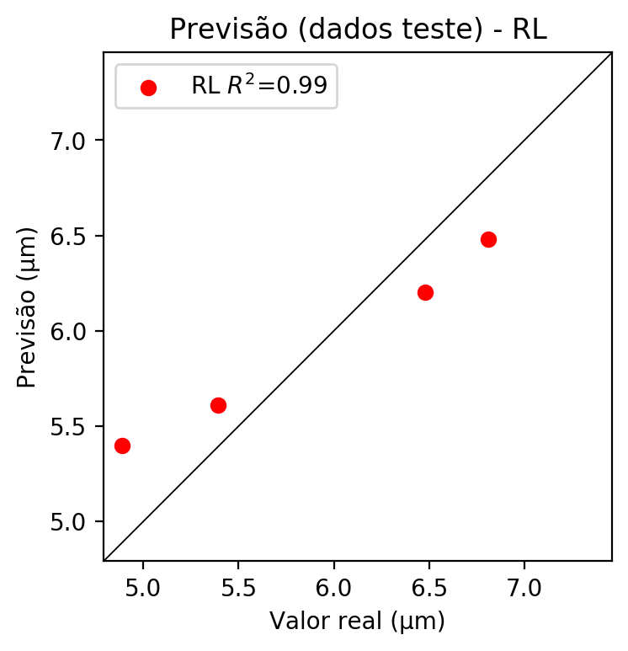

**Dados de treino**

* Erro relativo médio: 3.63
* Coeficiente de correlação: 0.86
* Coeficiente de determinação: 0.74
* MSE: 0.06
* RMSE: 0.24

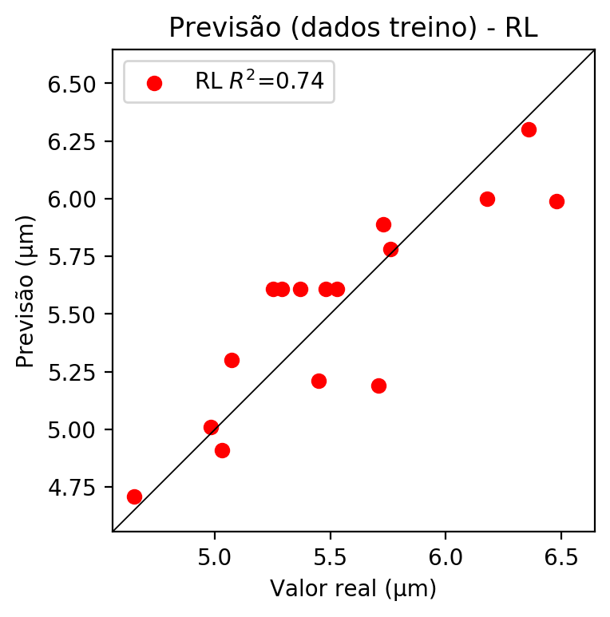

# RP2

# Coeficientes

[ 0. -0.31109797 0.37118575 0.52321122 0.19539883 0.1300435  
 0.28924412 0.0301415 0.17444498 0.11184823]

# Erros

**Dados de teste**

* Erro relativo médio: 7.41
* Coeficiente de correlação: 0.92
* Coeficiente de determinação: 0.84
* MSE: 0.25
* RMSE: 0.5

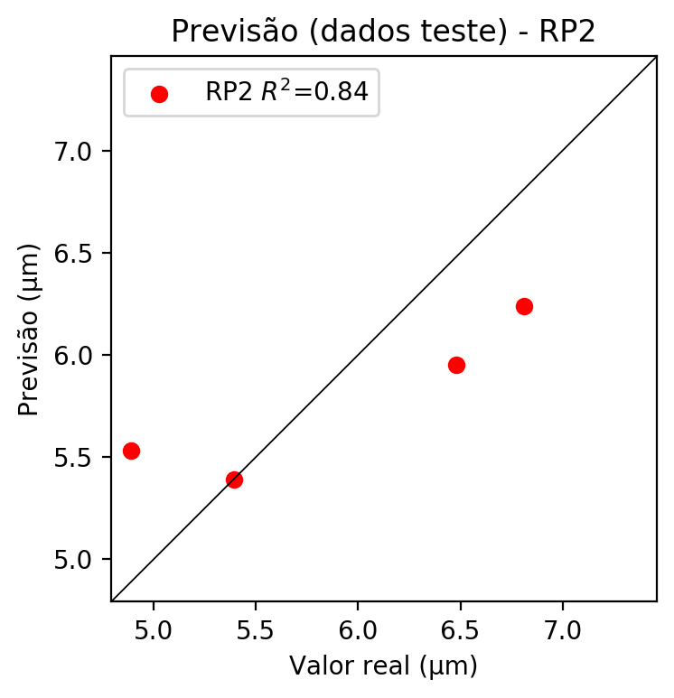

**Dados de treino**

* Erro relativo médio: 0.68
* Coeficiente de correlação: 0.99
* Coeficiente de determinação: 0.98
* MSE: 0.0
* RMSE: 0.0

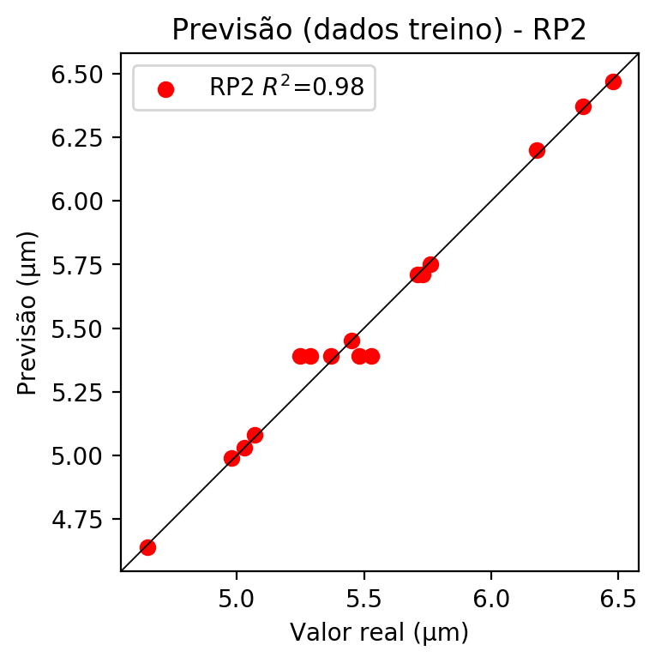

# RP3

# Coeficientes

[-2.77555756e-17 -4.79221982e-02 5.57381703e-02 8.11939990e-02  
 1.86147789e-01 1.36918890e-01 2.95264880e-01 4.18519235e-02  
 1.54100775e-01 1.08224843e-01 -6.81348664e-02 8.73411346e-02  
 1.41503413e-01 -6.23194172e-02 2.27111259e-02 -6.41250909e-02  
 7.45630591e-02 9.77348972e-02 6.33977500e-02 9.24668037e-02]

# Erros

**Dados de teste**

* Erro relativo médio: 7.57
* Coeficiente de correlação: 0.92
* Coeficiente de determinação: 0.84
* MSE: 0.27
* RMSE: 0.52

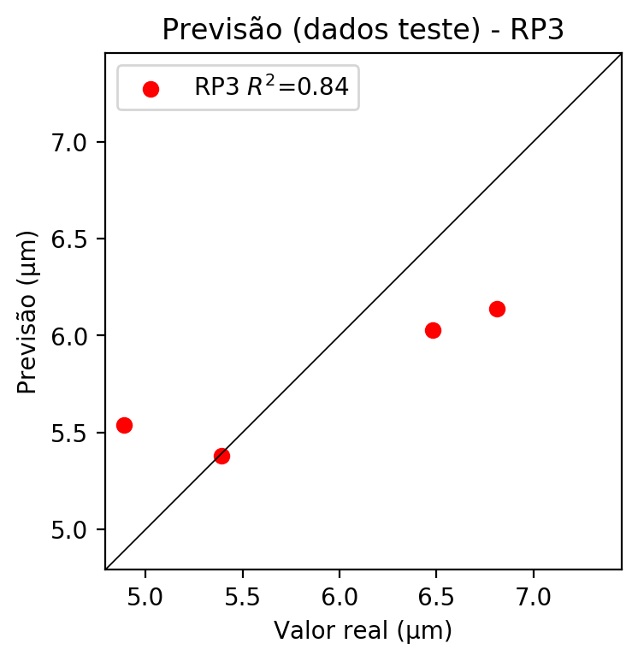

**Dados de treino**

* Erro relativo médio: 0.56
* Coeficiente de correlação: 0.99
* Coeficiente de determinação: 0.99
* MSE: 0.0
* RMSE: 0.0

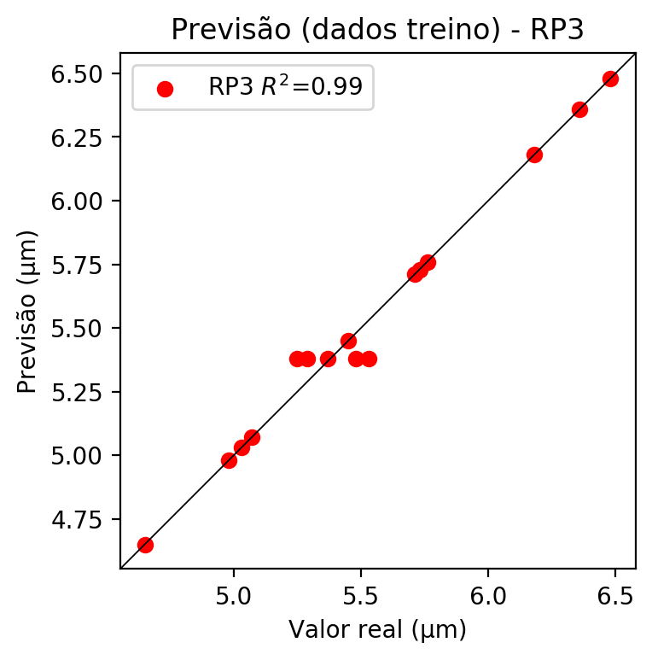

# RP4

# Coeficientes

[ 0. -0.03065179 0.0347668 0.06916024 0.02929828 0.03393442  
 0.06683304 0.01814463 0.00470248 0.02330935 -0.07045696 0.04723743  
 0.09863185 -0.02255989 0.08061102 -0.0227004 0.05411931 0.07755438  
 0.03700766 0.09584798 0.04143879 0.05240363 0.10353904 0.03521987  
 0.01328734 0.03522369 0.03994798 0.07948866 0.0404135 0.07899098  
 -0.00642374 0.0055842 0.03087024 0.0055842 0.01810871]

# Erros

**Dados de teste**

* Erro relativo médio: 11.33
* Coeficiente de correlação: 0.32
* Coeficiente de determinação: 0.1
* MSE: 0.65
* RMSE: 0.81

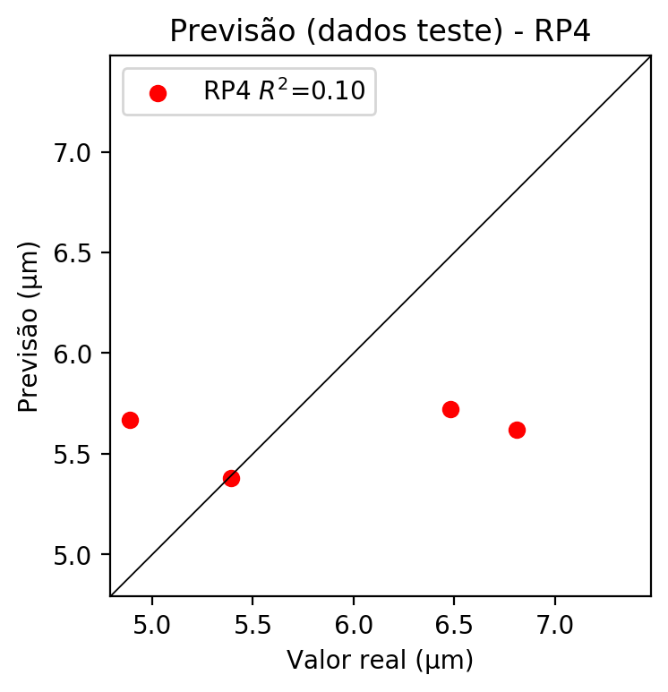

**Dados de treino**

* Erro relativo médio: 0.56
* Coeficiente de correlação: 0.99
* Coeficiente de determinação: 0.99
* MSE: 0.0
* RMSE: 0.0

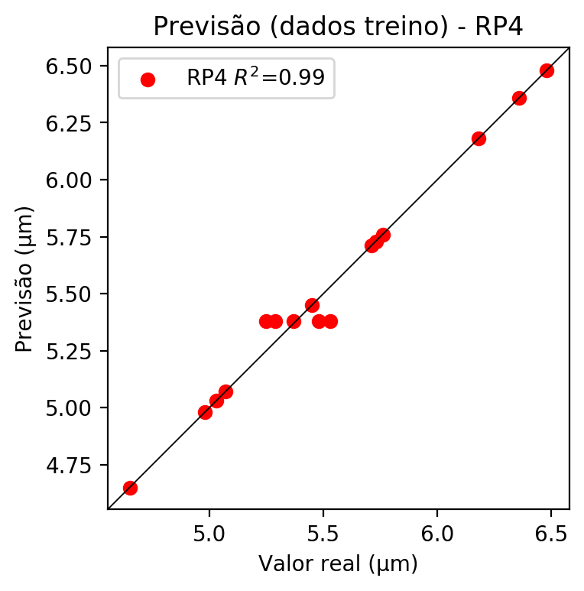

# Geral

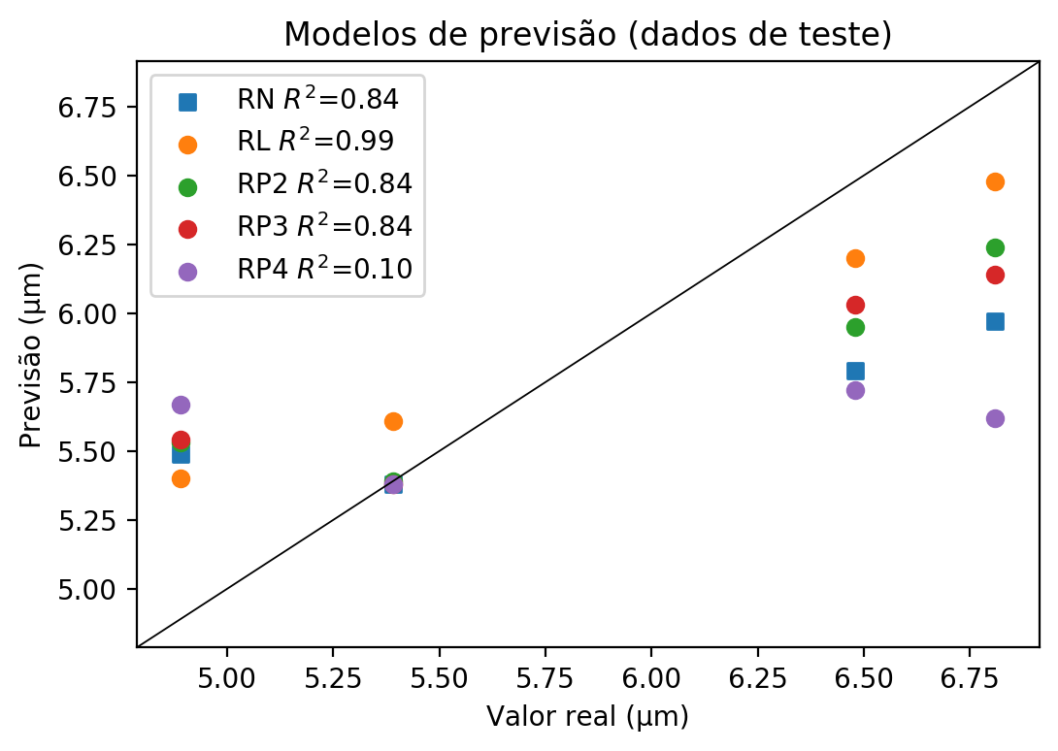

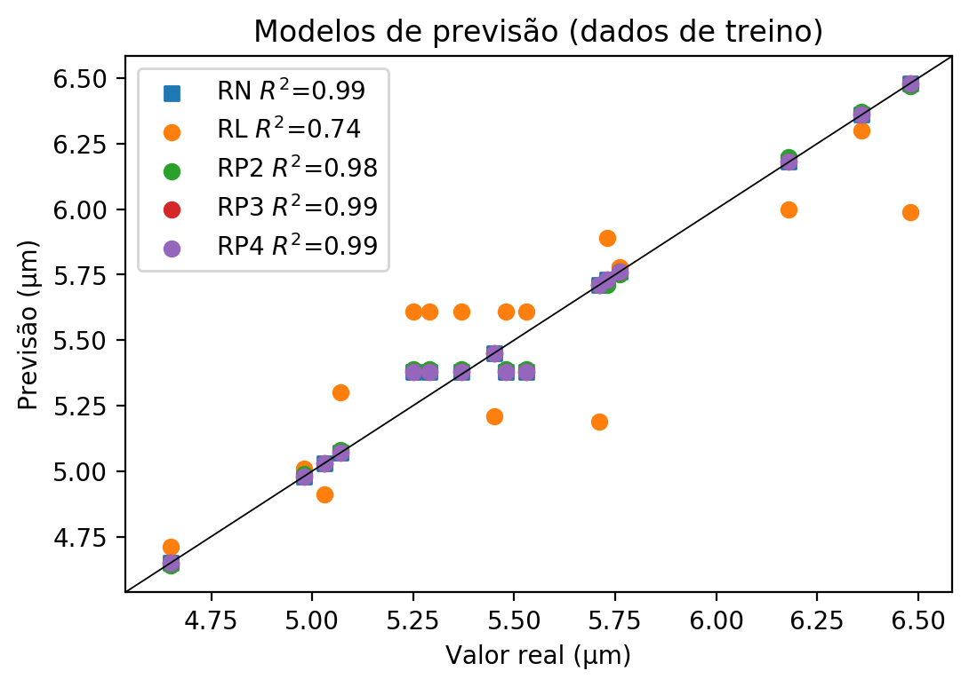

**Dados de teste**

|  |  |  |  |  |  |  |  |  |  |  |
| --- | --- | --- | --- | --- | --- | --- | --- | --- | --- | --- |
| Valor real | RN Previsto | RN Erro (%) | RL Previsto | RL Erro (%) | RP2 Previsto | RP2 Erro (%) | RP3 Previsto | RP3 Erro (%) | RP4 Previsto | RP4 Erro (%) |
| 6.48 | 5.79 | 10.65 | 6.2 | 4.32 | 5.95 | 8.18 | 6.03 | 6.94 | 5.72 | 11.73 |
| 4.89 | 5.49 | 12.27 | 5.4 | 10.43 | 5.53 | 13.09 | 5.54 | 13.29 | 5.67 | 15.95 |
| 6.81 | 5.97 | 12.33 | 6.48 | 4.85 | 6.24 | 8.37 | 6.14 | 9.84 | 5.62 | 17.47 |
| 5.39 | 5.38 | 0.19 | 5.61 | 4.08 | 5.39 | 0.0 | 5.38 | 0.19 | 5.38 | 0.19 |

**Dados de treino**

|  |  |  |  |  |  |  |  |  |  |  |
| --- | --- | --- | --- | --- | --- | --- | --- | --- | --- | --- |
| Valor real | RN Previsto | RN Erro (%) | RL Previsto | RL Erro (%) | RP2 Previsto | RP2 Erro (%) | RP3 Previsto | RP3 Erro (%) | RP4 Previsto | RP4 Erro (%) |
| 5.48 | 5.38 | 1.82 | 5.61 | 2.37 | 5.39 | 1.64 | 5.38 | 1.82 | 5.38 | 1.82 |
| 6.48 | 6.48 | 0.0 | 5.99 | 7.56 | 6.47 | 0.15 | 6.48 | 0.0 | 6.48 | 0.0 |
| 5.29 | 5.38 | 1.7 | 5.61 | 6.05 | 5.39 | 1.89 | 5.38 | 1.7 | 5.38 | 1.7 |
| 5.73 | 5.73 | 0.0 | 5.89 | 2.79 | 5.71 | 0.35 | 5.73 | 0.0 | 5.73 | 0.0 |
| 5.07 | 5.07 | 0.0 | 5.3 | 4.54 | 5.08 | 0.2 | 5.07 | 0.0 | 5.07 | 0.0 |
| 4.98 | 4.98 | 0.0 | 5.01 | 0.6 | 4.99 | 0.2 | 4.98 | 0.0 | 4.98 | 0.0 |
| 5.25 | 5.38 | 2.48 | 5.61 | 6.86 | 5.39 | 2.67 | 5.38 | 2.48 | 5.38 | 2.48 |
| 5.76 | 5.76 | 0.0 | 5.78 | 0.35 | 5.75 | 0.17 | 5.76 | 0.0 | 5.76 | 0.0 |
| 5.45 | 5.45 | 0.0 | 5.21 | 4.4 | 5.45 | 0.0 | 5.45 | 0.0 | 5.45 | 0.0 |
| 5.37 | 5.38 | 0.19 | 5.61 | 4.47 | 5.39 | 0.37 | 5.38 | 0.19 | 5.38 | 0.19 |
| 6.36 | 6.36 | 0.0 | 6.3 | 0.94 | 6.37 | 0.16 | 6.36 | 0.0 | 6.36 | 0.0 |
| 5.53 | 5.38 | 2.71 | 5.61 | 1.45 | 5.39 | 2.53 | 5.38 | 2.71 | 5.38 | 2.71 |
| 5.03 | 5.03 | 0.0 | 4.91 | 2.39 | 5.03 | 0.0 | 5.03 | 0.0 | 5.03 | 0.0 |
| 4.65 | 4.65 | 0.0 | 4.71 | 1.29 | 4.64 | 0.22 | 4.65 | 0.0 | 4.65 | 0.0 |
| 6.18 | 6.18 | 0.0 | 6.0 | 2.91 | 6.2 | 0.32 | 6.18 | 0.0 | 6.18 | 0.0 |
| 5.71 | 5.71 | 0.0 | 5.19 | 9.11 | 5.71 | 0.0 | 5.71 | 0.0 | 5.71 | 0.0 |